

Mailit installation guide

By Matthew Karko



# Installation Guide

To install the prerequisites to run the program, please follow the following steps:

1. Make sure you have the latest version of Windows 10 installed
2. Ensure that your machine meets the minimum hardware requirements to run the program
3. Head to <https://www.python.org/downloads/> and download the latest version of python
4. Open the command prompt window as administrator and do the following:
   1. 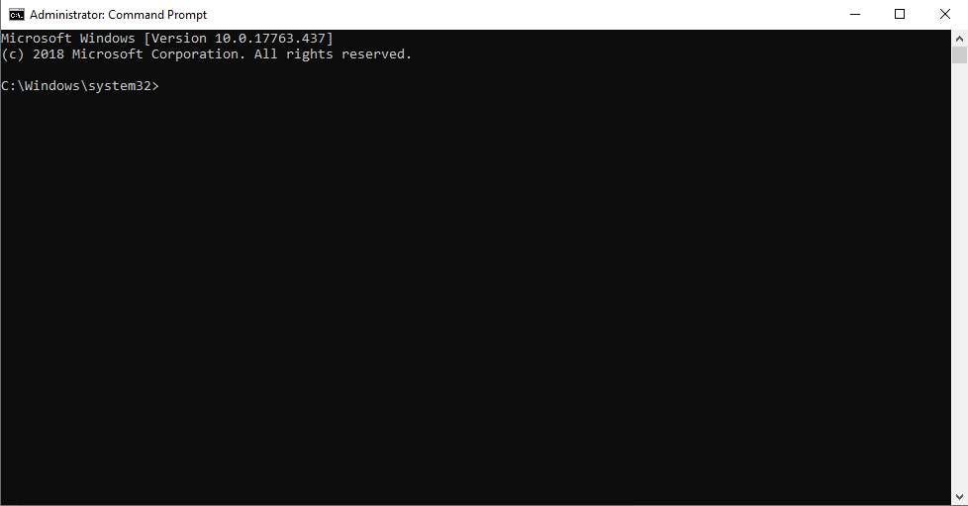A window like this should pop up
   2. Ensure that you have the latest pip version installed through this line:
      1. python -m pip install --upgrade pip wheel setuptools
   3. Install these kivy dependancies:
      1. python -m pip install docutils pygments pypiwin32 kivy.deps.sdl2 kivy.deps.glew
      2. python -m pip install kivy.deps.gstreamer
   4. Install kivy:
      1. python -m pip install kivy
   5. Install pandas for excel files:
      1. Python -m pip install pandas
   6. Install xlrd for excel files:
      1. Python -m pip install xlrd
   7. These should look like this: 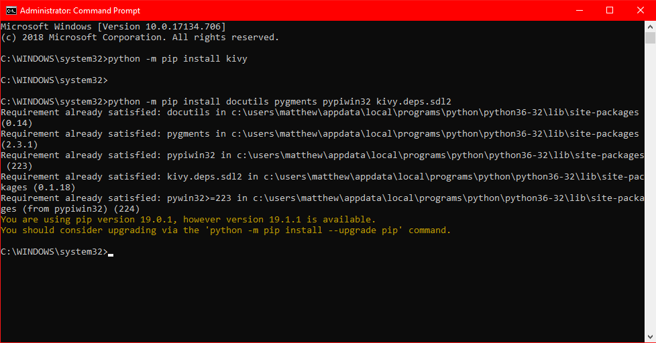
   8. However, since I already have them installed it has responded with this, yours should look different.
5. Run the python file and open up the kivy file with your client. Preferably Microsoft Visual Studio Code which can be found here: <https://code.visualstudio.com/download>
6. Run the python file!

If you have any issues with the installation process or locating the requirements please don’t hesitate to reach out to us. You can contact us through :

* [bphsalerts@gmail.com](mailto:bphsalerts@gmail.com)
* TEL: 0413 546 756

For any further assistance please refer to:

Pythons website: <https://www.python.org/downloads/>

Kivy’s website: <https://kivy.org/#home>